Star chemistry
Did you know?
About radio telescopes

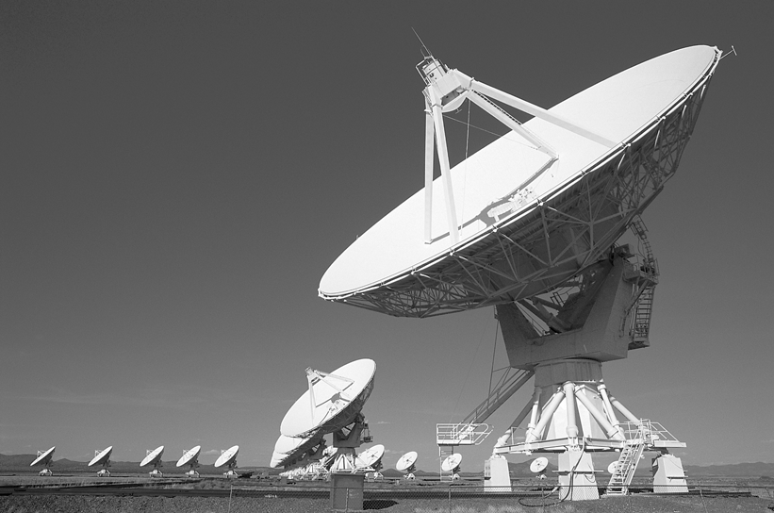

Astronomers use radio telescopes to detect molecules in the ISM. The tiny molecules are always spinning and vibrating due to the energy that they absorb from stars. Sometimes their energy level changes. Usually this means that they give out a tiny amount of energy. The energy is at a specific frequency. The frequency can be detected by a radio telescope. Each molecule produces a 'fingerprint' signal which can be matched to those known on Earth. Astronomers can then identify the molecules.



